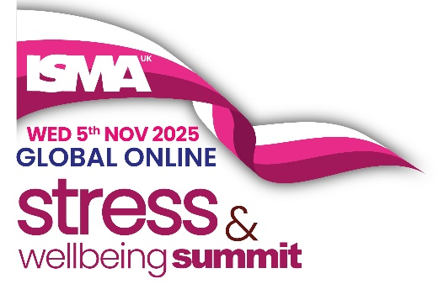

Agenda
Online Global Stress & Wellbeing Summit 2025
Wednesday 5 November 2025 | Live Online
Time | Session Title | Description | Speakers and Moderators
09:15–09:25 | Introduction | Opening address by the event MC to welcome attendees and introduce the day’s theme. | Alastair Greener, Event MC, Presenter, and Founder of Present Yourself
09:25–09:30 | Welcome from ISMAUK | A formal welcome from ISMAUK’s Chair and founder of International Stress Awareness Week. | Carole Spiers, Chair of ISMAUK
09:30–10:30 | Session 1: Strategic Stress Management - Ethical Leadership and Standards for Thriving Cultures | This interactive panel explores the critical role of ethical leadership and upcoming changes to the HSE Management Standards. It addresses legal implications, SME challenges, and building workplace cultures where employees thrive. Includes Q&A. | Professor Sir Cary Cooper CBE, Peter Kelly, Clare Fernandes, Nick Pahl. Moderated by Amy McKeown
10:30–11:00 | Session 2: Turn On, Tune In, Tune Out | A practical session with energy-boosting strategies to start your day, stay focused at work, and wind down for restorative rest. Learn to recalibrate your daily rhythm for improved wellbeing. | Celynn Morin
11:30–12:30 | Session 3: Where Stress Management Fits - Inclusivity and Adaptability in the Workplace | A panel discussion on how inclusive and adaptive cultures can thrive. Topics include gender equity, supporting older workers, neuroscience-informed HR practices, and the role of front-line managers in promoting mental health. Includes Q&A. | Paul Devoy, Dr Lynda Shaw, Dame Carol Black, Shelley Bridgman. Moderated by Dr Laura Ginesi
13:00–14:00 | Session 4: Change Your State - Mantra Music Meditation and Breathwork | Discover how mantra, breathwork, and ancient techniques can be used to reduce stress, sharpen focus, and build emotional resilience. A guided experiential session tailored for busy professionals. | Prash Kotecha
15:00–16:00 | Session 5: Raising the Flag for Mental Health - Advocacy and Role Models | A panel discussion on the role of mental health champions in reducing stigma and promoting safe, supportive workplaces. Learn how advocacy, training, and crisis response strategies can drive lasting organisational change. Includes Q&A. | Rachel Perkins OBE, Sarah McIntosh, Adam Pavey, Andy Baines-Vosper. Moderated by Paul Dorrington
16:00–16:30 | Session 6: Negative Thinking - Strategies to Improve Mental Clarity | This session explores the impact of negative thought patterns on stress and wellbeing. Learn practical strategies to shift your mindset and improve emotional health in everyday life. | Heather Wright
17:00–17:30 | Session 7: Stress Management Awards Presentation | Announcement of the 2025 Bronze, Silver, and Gold Award winners. This session celebrates outstanding contributions to mental health and stress reduction across UK organisations. | Moderated by Emma Pennycard
17:30–18:30 | Session 8: Getting to Know You | A relaxed networking session open to all delegates. Meet speakers, fellow attendees, and members of the ISMAUK team in an informal virtual setting. | Hosted by Carole Spiers, Chair of ISMAUK

